BOOK - Peopleware. Productive Projects and Teams

Peopleware: Productive Projects and Teams (Second Edition) Paperback – February 1, 1999
https://www.amazon.com/Peopleware-Productive-Projects-Teams-Second/dp/0932633439
 | | | 4.5 out of 5 stars | | | 109 customer reviews

Images

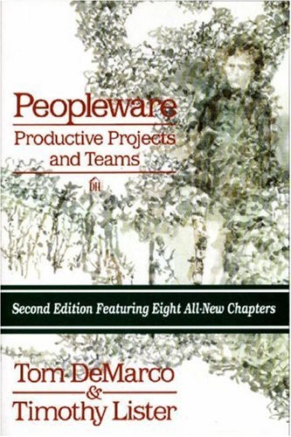
Book Description
Demarco and Lister demonstrate that the major issues of software development are human, not technical. Their answers aren't easy--just incredibly successful. New second edition features eight all-new chapters. Softcover. Previous edition: c1987. DLC: Management.

Aus <https://www.amazon.com/Peopleware-Productive-Projects-Teams-Second/dp/0932633439>

